

**Progress report: deliverable on Project D13-0379 – Darwin – East Arm Port Project**

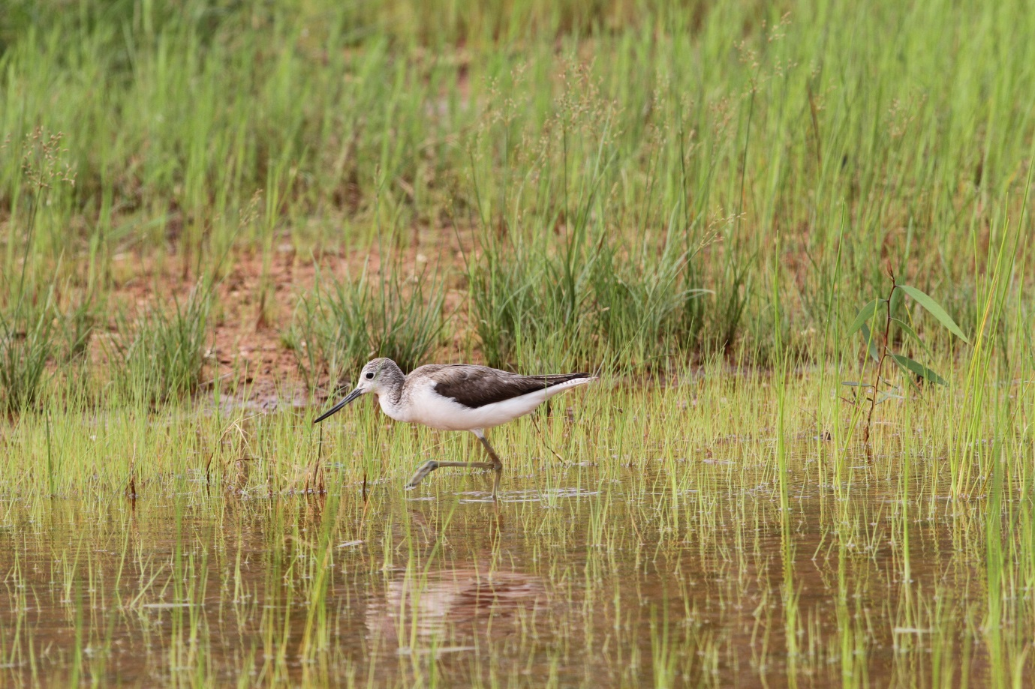

Report to the northern territory government

31 January 2015

**Amanda Lilleyman, Michael J. Lawes and Stephen T. Garnett**

Research Institute for the Environment and Livelihoods, Charles Darwin University, Darwin 0909, Northern Territory

Lilleyman, A., Lawes, M.J. and Garnett, S.T. 2015. Progress report: deliverable on Project D13-0379 – Darwin – East Arm Port Project. Report to the Department of Business, Northern Territory Government

31 JANUARY 2015

Front cover image credit: Amanda Lilleyman

# TABLE OF CONTENTS

TABLE OF CONTENTS 1

BACKGROUND 2

2014-15 SHOREBIRD COUNTS FOR EAST ARM WHARF 3

CONCLUSIONS 7

ACKNOWLEDGEMENTS 7

REFERENCES 7

APPENDICES 7

# BACKGROUND

This progress report provides an update on the monitoring of migratory shorebirds that roost in the dredge ponds at East Arm Wharf (EAW). Monitoring began in late 2009 and continued through the survey efforts of Conservation Volunteers Australia (CVA). A PhD research project currently being undertaken by Amanda Lilleyman has worked alongside the monitoring program established by CVA. The current report builds on from the May 2014 report summarising the shorebird monitoring program (Lilleyman et al. 2013, 2014).

This project assesses the importance of Darwin Harbour for migratory shorebirds (listed in Table 1) protected under the *Environmental Protection and Biodiversity Conservation Act* *1999* (EPBC Act).

**Table 1. Migratory shorebird species monitored at East Arm Wharf.**

|  |  |  |  |
| --- | --- | --- | --- |
| Shorebird | Scientific name | Shorebird | Scientific name |
| Pacific Golden Plover | *Pluvialis fulva* | Common Greenshank | *Tringa nebularia* |
| Grey Plover | *Pluvialis squatarola* | Marsh Sandpiper | *Tringa stagnatilis* |
| Lesser Sand Plover | *Charadrius mongolus* | Wood Sandpiper | *Tringa glareola* |
| Greater Sand Plover | *Charadrius leschenaulltii* | Ruddy Turnstone | *Arenaria interpres* |
| Oriental Plover | *Charadrius verenus* | Asian Dowitcher | *Limnodromus semipalmatus* |
| Black-tailed Godwit | *Limosa limosa* | Great Knot | *Calidris tenuirostris* |
| Bar-tailed Godwit | *Limosa lapponica* | Red Knot | *Calidris canutus* |
| Whimbrel | *Numenius phaeopus* | Sanderling | *Calirdis alba* |
| Eastern Curlew | *Numenius madagascariensis* | Red-necked Stint | *Calidris ruficollis* |
| Terek Sandpiper | *Xenus cinereus* | Sharp-tailed Sandpiper | *Calidris acuminata* |
| Common Sandpiper | *Actitus hypoleucos* | Curlew Sandpiper | *Calirdris ferruginea* |
| Grey-tailed Tattler | *Tringa brevipes* | Broad-billed Sandpiper | *Calidris falcinellus* |

# 2014-15 SHOREBIRD COUNTS FOR EAST ARM WHARF

Counts of migratory shorebirds were conducted each fortnight with most counts performed during spring high tides and some during neap high tides and low tides. All dredge ponds were surveyed for migratory shorebirds, and all other waterbirds were also recorded.

Shorebird abundance varied according to the timing of the season, with September supporting the most individuals and species of migratory shorebirds in Pond E at high tide (Figure 1). The high number of shorebirds in September is due to the birds arriving in Darwin during their southward migration from their breeding grounds. Many shorebirds appear to use the Darwin region for a ‘staging’ area, resting and feeding after flying south from east Asia before moving to their preferred non-breeding site.



**Figure 1. Maximum count of migratory shorebirds in the different dredge ponds at East Arm Wharf for months May 2014 through to January 2015.**

September is the most important month for migratory shorebirds at EAW as almost 1000 individuals of up to 17 species used Pond E as a roost site during high tides (Figure 2). Because of this, EAW meets the criteria as a site of national importance under the *Significant impact guidelines for 36 migratory shorebird species* – a background paper to the EPBC Act Policy Statement 3.21 as it has supported more than 15 species at a single time (Australian Government 2009).



**Figure 2. Maximum number of shorebird species in the different dredge ponds at East Arm Wharf from May 2014 through to January 2015. Letters above bars represent the dredge pond that supported the maximum count of species.**

The highest number of species that other known roost sites have supported (over the course of this study period) is 14 (Lee Point beach). It is likely that EAW supports a great number of migratory shorebird species because of the variety of habitat available and the size of the roosting area. East Arm Wharf provides freshwater habitat in ponds B and D (when there are no dredging activities) and K and E provide saline (and somewhat tidal) habitats with the EAW as a whole providing ready access to coastal mudflats within easy reach of the EAW. The December count at EAW, in which small numbers of 14 species, is consistent with this hypothesis. However species richness and abundance dropped when freshwater flooded the ponds leaving little of the exposed muddy edge that migratory shorebirds prefer. With the drying of the ponds once the monsoon settles (expected in Mar/Apr), numbers are likely to rise again before the northward migration to the birds’ breeding grounds in north Asia and Alaska.

Fortnightly counts at all of the ponds revealed much variation across the EAW site and over time, demonstrating how dynamic the shorebird community can be as a result of both annual long distance movement through and past Darwin and short term movements between sites depending on the tide, food availability and food requirements (Figure 3).



**Figure 3. Migratory shorebird counts for all dredge ponds (blue line) and in Pond D (red line) at East Arm Wharf from May 2014 through to January 2015.**

# CONCLUSIONS

1. In the nine months since the last progress report the migratory shorebirds have returned to Darwin for the non-breeding season, with September supporting the most individuals and species. These large concentrations occurred in Pond E.
2. Pond D has continued to provide quality habitat for migratory shorebirds during the monitoring period. The lack of water available in Pond D from July to October meant that shorebirds used Pond E as their main roosting pond. When rainwater filled to Pond D, the birds also returned.
3. Ponds E, D and K have all supported nationally significant numbers of shorebirds
4. The final report in this contract (to be submitted April 2015) will discuss the use of the harbour by shorebirds that roost at EAW.

# ACKNOWLEDGEMENTS

Thank you to Conservation Volunteers Australia and Darwin Port Corporation for supporting the migratory shorebird monitoring program.

# REFERENCES

Australian Government. 2009. Significant impact guidelines for 36 migratory shorebird species.*in* Department of Environment Water Heritage and the Arts, editor.

Lilleyman, A., Lawes, M. and Garnett, S.T.. 2013. Migratory shorebirds in Darwin harbour, Northern Territory. Report to the Department of Business, Northern Territory Government. 31 October 2013

Lilleyman, A., Lawes, M. and Garnett, S.T.. 2014. Migratory shorebirds in Darwin harbour, Northern Territory. Report to the Department of Business, Northern Territory Government. 31 January 2014

# APPENDICES

**Appendix 1. Migratory shorebird monitoring abundance data May 2014 through to January 2015.**











